## Q1:-Design a home page which will display your information i.e., Bio data, also Create Hyperlinks in home page i.e., educational details, Hobbies, Achievement, My Ideals etc.

<!doctype html>

<html>

<head>

<Title> Home Page</Title>

</head>

<body>

<p><b><center> BIODATA </p></center></b>

<p><b> Full Name : </b> Krishant Chauhan </p>

<p><b> Date of Birth : </b> Date of Birth : 20/08/2000</p>

<p><b>Place of Birth: </b>Place of Birth: Ambala</p>

<p> <b>Height :</b> 172cm</p>

<p> <b>Weight :</b>57kg</p>

<p><b>Blood Groupt:</b> O<sup>+</sup></p>

<p><b>Education :</b>BCA final year</p>

<p><b>Contact Number:</b> 7017335516</p>

<b>Educational details </b><br>

<a href="education.html"> Click here </a><br><br>

<b>Hobbies<b><br>

<a href="Hobbies.html"> Click here </a><br><br>

<b>Achievement</b><br>

<a href="Achievement.html"> Click here </a><br><br>

<b>My Ideals </b><br>

<a href="MyIdeals.html"> Click here </a><br>

</body>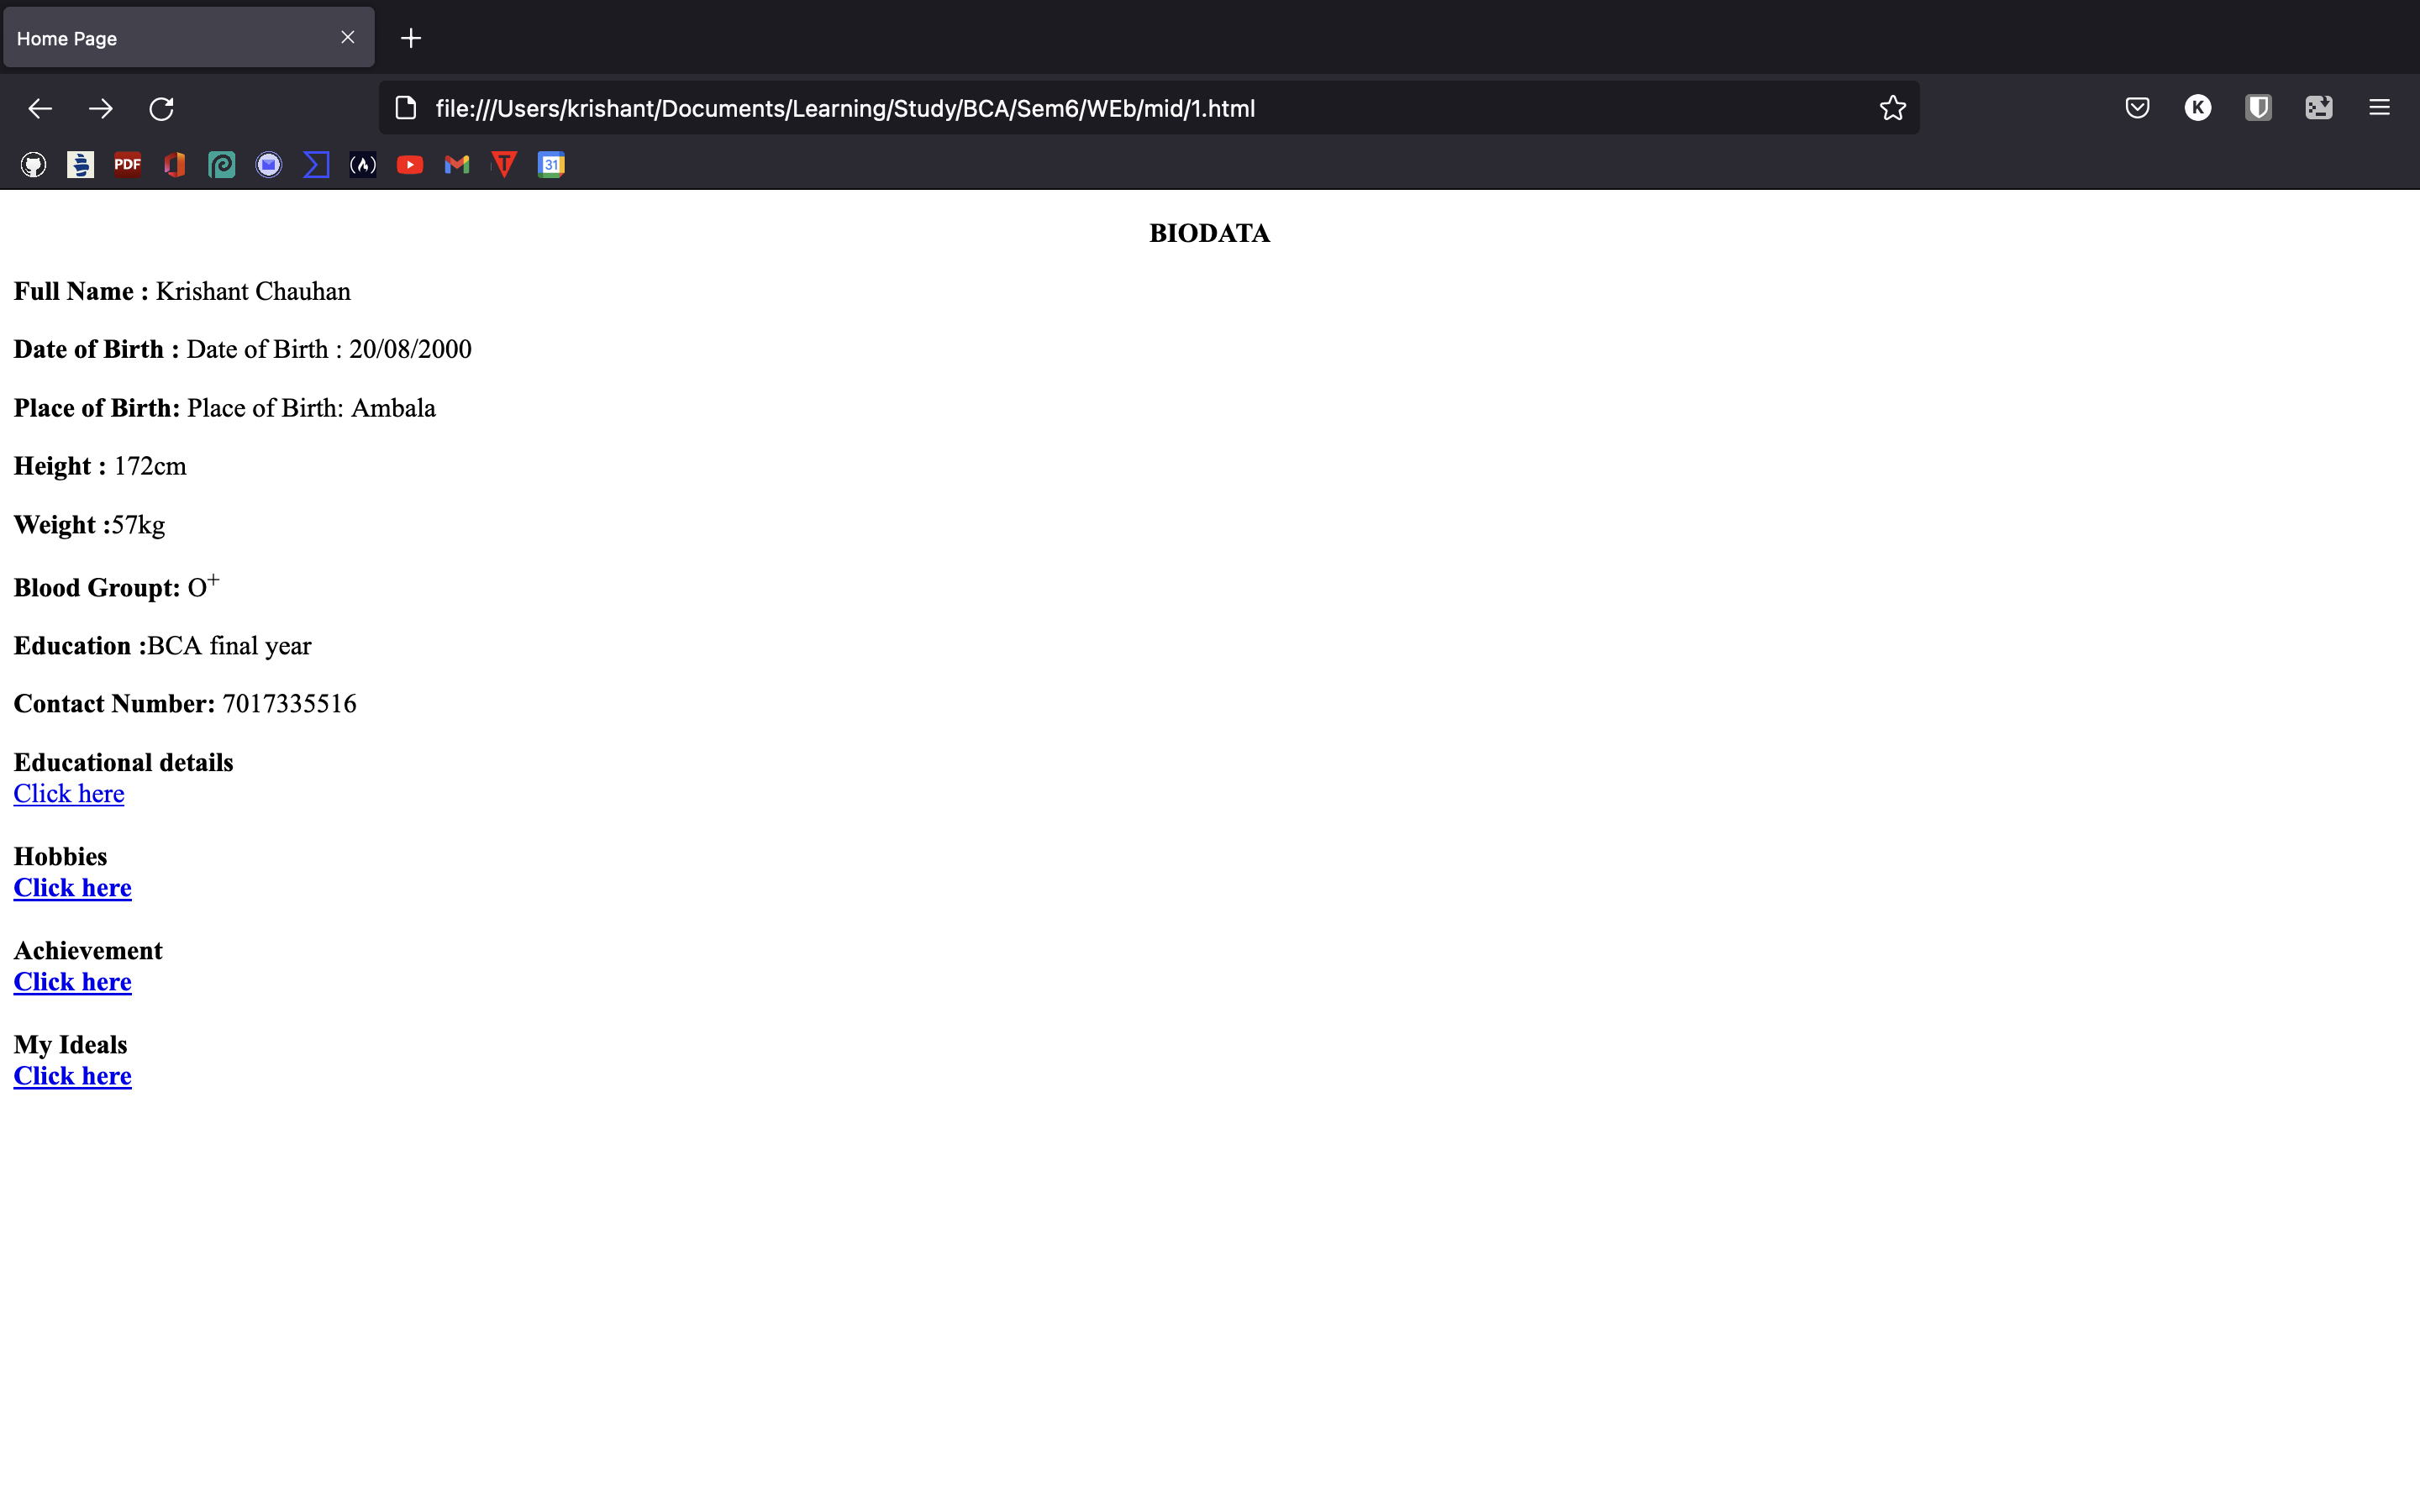</html>

## Q2:-Design a web page of your department and create internal hyperlinks in MCA, BCA, and Bsc IT, also creates links on the words AICTE, and UGC and link them to Wikipedia pages.

<html>

<head>

<title>GEHU</title>

</head>

<body>

<a href="#MCA" >MCA</a><br>

<a href="#BCA">BCA</a><br>

<a href="#BSCIT">BSC</a><br>

<a href="https://en.wikipedia.org/wiki/All_India_Council_for_Technical_Education

">AICTE</a><br>

<a href="https://en.wikipedia.org/wiki/University_Grants_Commission_(India)">UGC

</a> <br><br><br><br><br><br>

<p><a name="MCA"><mark> This is MCA Batch</mark></a></p>

<br><br><br><br><br><br><br><br>

<p><a name="BCA"><mark>This is BCA Batch</mark></a></p>

<br><br><br><br><br><br><br>

<p><a name="BSCIT"><mark>This is BSCIT batch</mark></a></p>

</body> </html>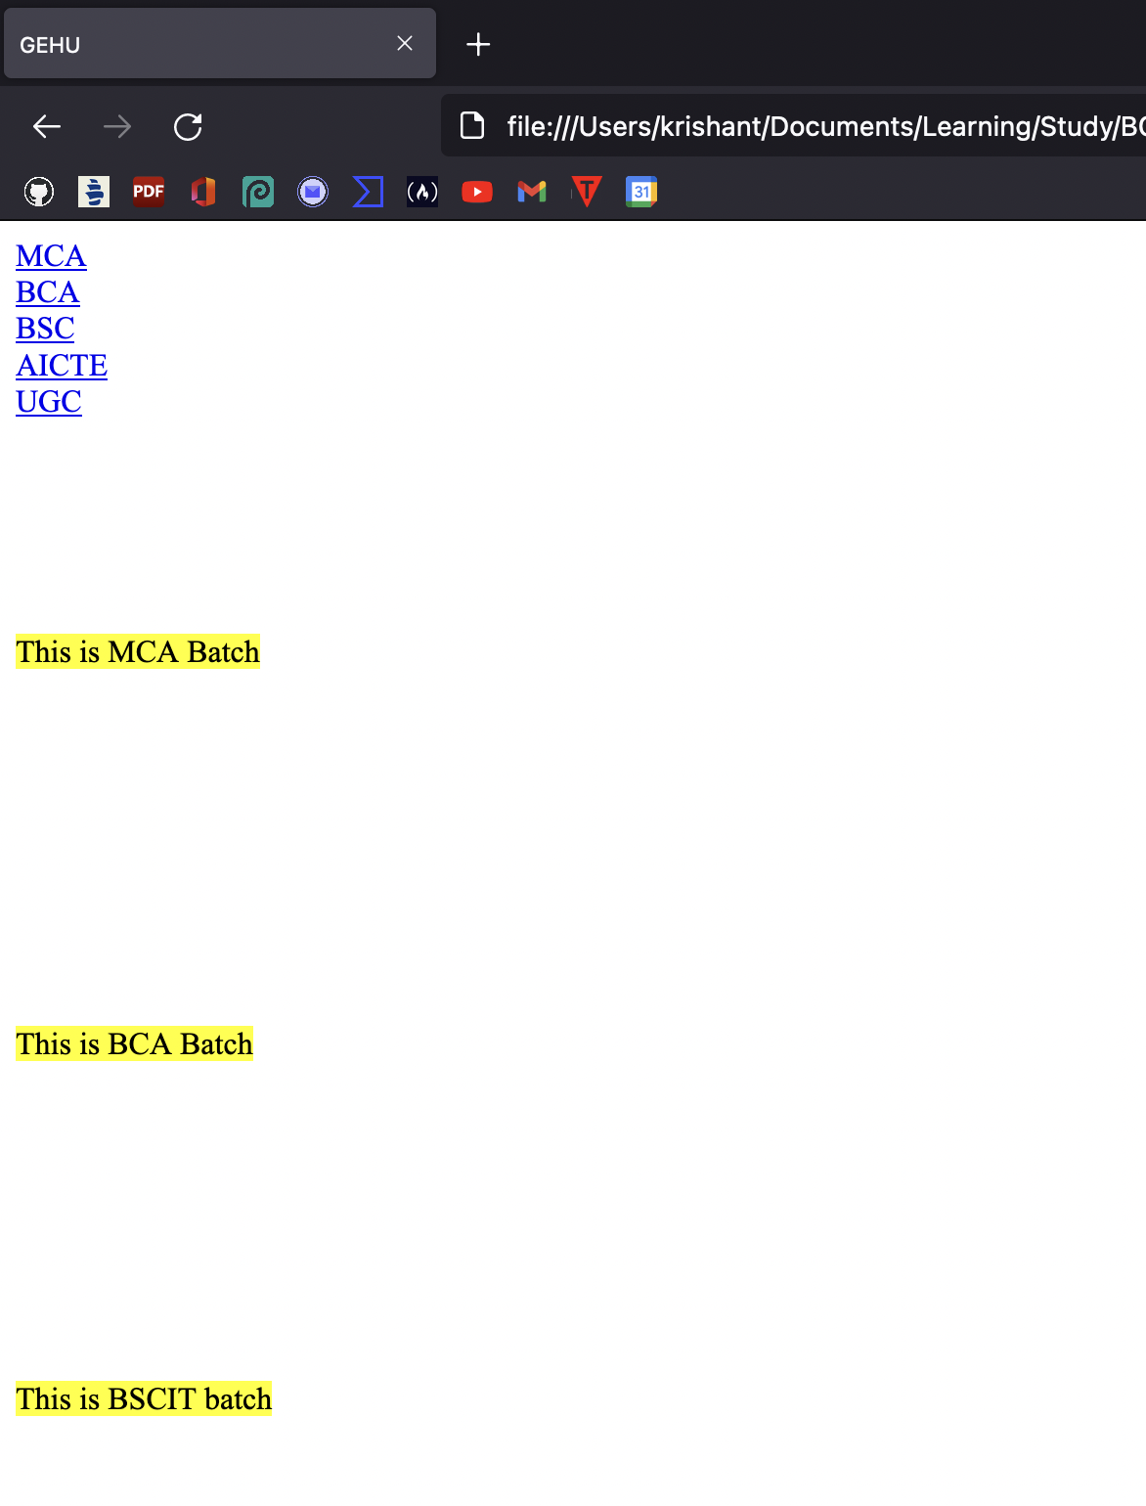

## Q3:-Design a web page with the following:

## To embed an image map in a web page

<html>

<head>

<title>Image Mapping</title>

</head> <body>

<img src="pic.png" alt="alert text for image if image is not visible" usemap ="#image name" width="400" height="400"> <map name="image name">

<area shape="rect" coords="34,44,270,350" alt="hut" href="BaseLinking.html">

<area shape="circle" coords="300,300,100" alt="tree"href="InternalHyperlink.html"> </map>

</body>

</html>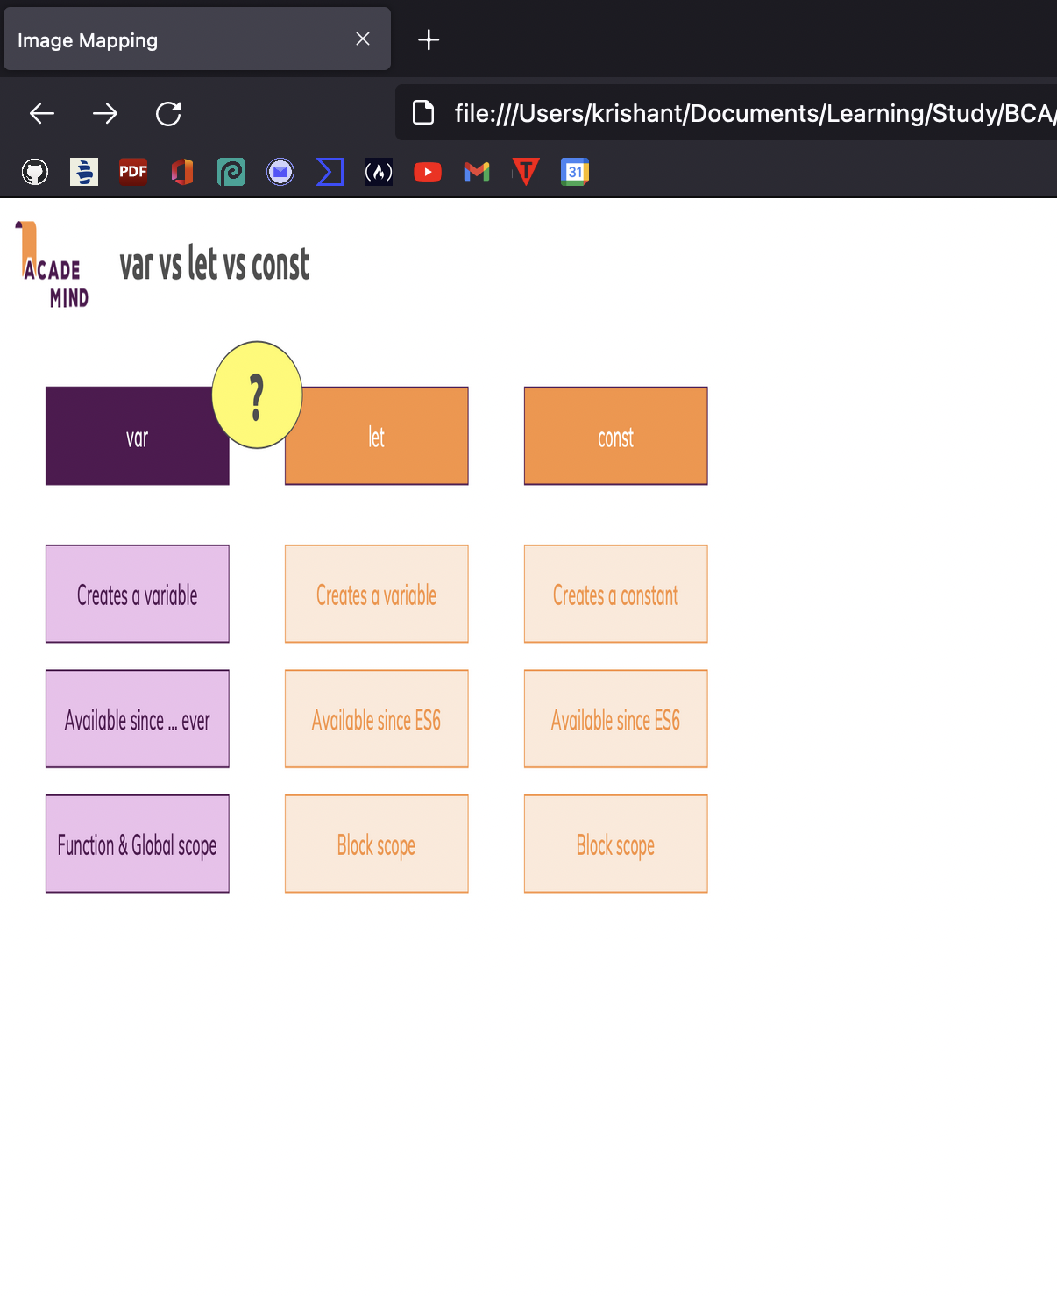

## To fix the hot spots

<html>

<head>

<title>GEHU</title>

<base href="https://www.gehu.ac.in/">

</head>

<body>

<p>click link</p>

<a href="/html/index.html" target="_blank">open in new</a><br>

<a href="/html/index.html" target="_self">open in self</a><br>

<a href="/html/index.html" target="_parent">open in parent</a><br>

<a href="/html/index.html" target="_top">open in body</a><br>

</body>

</html>

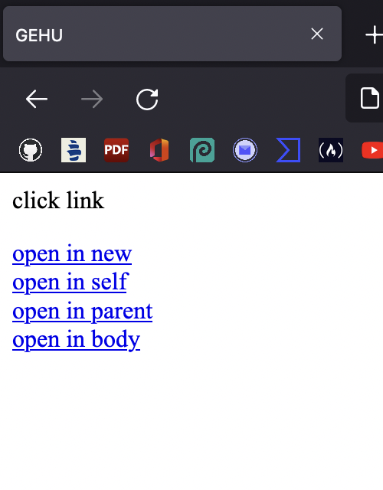

## Show all the related information when the hot spots are clicked.

<html>

<head>

<title>GEHU</title>

</head>

<body>

<a href="#MCA" >MCA</a><br>

<a href="#BCA">BCA</a><br>

<a href="#BSCIT">BSC</a><br>

<a href="https://en.wikipedia.org/wiki/All_India_Council_for_Technical_Education

">AICTE</a><br>

<a href="https://en.wikipedia.org/wiki/University_Grants_Commission_(India)">UGC

</a> <br><br><br><br><br><br>

<p><a name="MCA"><mark> This is MCA Batch</mark></a></p> <br><br><br><br><br><br><br><br>

<p><a name="BCA"><mark>This is BCA Batch</mark></a></p>

<br><br><br><br><br><br><br>

<p><a name="BSCIT"><mark>This is BSCIT batch</mark></a></p>

</body>

</html>

## Q4:-Create a web page to display departments and course information, using ordered and unordered list. Also describe the course information, using appropriate list type.

<!doctype html>

<html>

<head>

<Title> Ordered and Unordered list</title>

</head>

<body>

<ol type="1">

<li>Computer Application

<ul>

<li>BCA

<li>BSCIT

</ul>

<li>BTECH

<ul>

<li>BTECH CS

<li>BTECH Electrical

<li>Btech Mechanical

</ul>

<li>Medical

<ul>

<li>BSC Nursing

<li> BSC chemistry

</ul>

</body>

<html>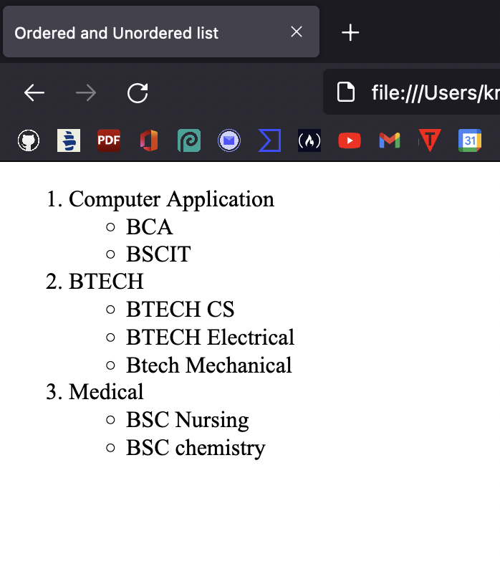

## Q5:-Design a timetable and display it in tabular format.

<!doctype html>

<html>

<head>

<Title>Time table</title>

</head>

<body>

<!-- <img src="graphic.png" align="center" width="200" height="200" > -->

<h3 ><center>SCHOOL OF COMPUTING</center></h3>

<h3 ><center>TIME-TABLE JAN-MAY 2022</center></h3>

<h4 > COURSE: BCA VI A</h4>

<center>

<table border="1" cellspacing="0">

<tr><th>Days</th><th>9:00-9:55</th><th>9:55-10:50</th><th>11:10-12:05 </th><th> 12:05-1:00 </th><th>1:00-1:55 </th><th> 1:55-2:50 </th><th> 3:10-4.05 </th><th>4.05-5.00 </th></tr> </tr> <tr>

<th>MON</th><th>TBC 601</th><th>TBC 603</th><th>SBC 601</th><th rowspan="6"> LUNCH BREAK</th><th colspan="4">PBC 601</th>

</tr><tr><th>TUE</th> <th> TBC 602 </th><th> TBC 603 </th><th> TBC 604 </th><th> </th> <th colspan="3"> PBC 602 </th></tr>

<tr><th>WED</th> <th> TBC 602 </th><th> TBC 604 </th><th> TBC 601 </th> <th> </th> <th > </th><th > </th>

<th > </th></tr>

<tr><th>THU</th> <th> TBC 603 </th><th> TBC 602 </th><th> TBC 604 </th><th> </th><th> </th><th> </th><th> </th></tr>

<tr><th>FRI</th> <th> TBC 601 </th><th> TBC 604 </th><th> </th></th><th> </th><th> </th><th> </th><th> </th>

</tr>

<tr><th>SAT</th> <th></th> <th></th> <th></th> </th><th> </th><th> </th><th></th><th> </th></tr>

</table>

</center>

</body>

</html>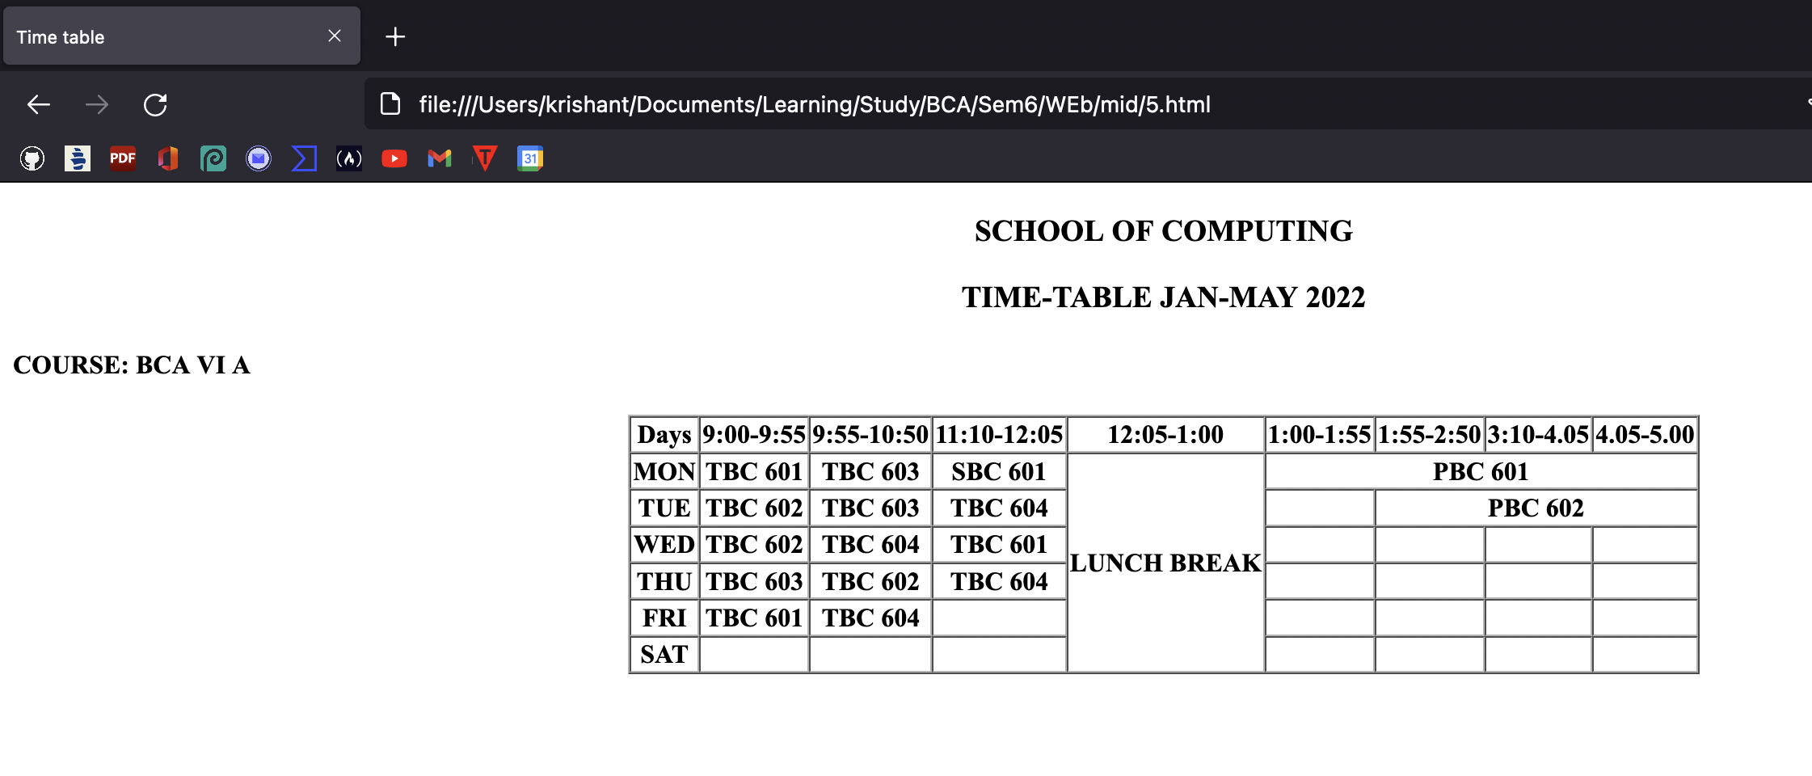

## Q6:(a) an html page named as “frames.html”. Divide the page into two columns of 20%, 80% size. In

## 20% size call the hyperlinks for “navigationframes.html”, “floatingframes.html”,

## “mixedframe.html”, “noframe” and make the page to be get displayed on the other column when these links are clicked.

//Main.html//

<html> <head>

<title>Frames</title> </head>

<frameset cols="20%,80%">

<frame src="Hyperlink.html" name="menu_page">

<frame src="framesmain.html" name="main_page">

</frameset> <noframes>

<body> Frames not supported

</body> </noframes> <html>

//hyperlink.html//

<!doctype html>

<html><head>

<title>Frames</title></head>

<body bgcolor="lightblue">

<a href="NavigationFrames.html"target="main_page">Navigation</a><br>

<a href="FloatingFrames.html"target="main_page">Floating Frames</a><br>

<a href="MixedFrame.html"target="main_page">MixedFrame</a><br>

</body> </html>

//Frames.html//

<!doctype html>

<html><head><title>Frames</title>

</head><body bgcolor="lightgreen">

<h1> This is main page and content from any link will be displayed here.</h1>

<p>so now click any link and see the result</p>

</body></html>

## B:-Create an html page named as “navigationframe.html”. Divide the page into two columns of 40%, 60% size. In 40% size call the hyperlink file created in above question, and make the page to be get displayed on the other column when the link is clicked.

**NavigationFrames.html**

<html>

<frameset cols ="40%,60%">

<frame src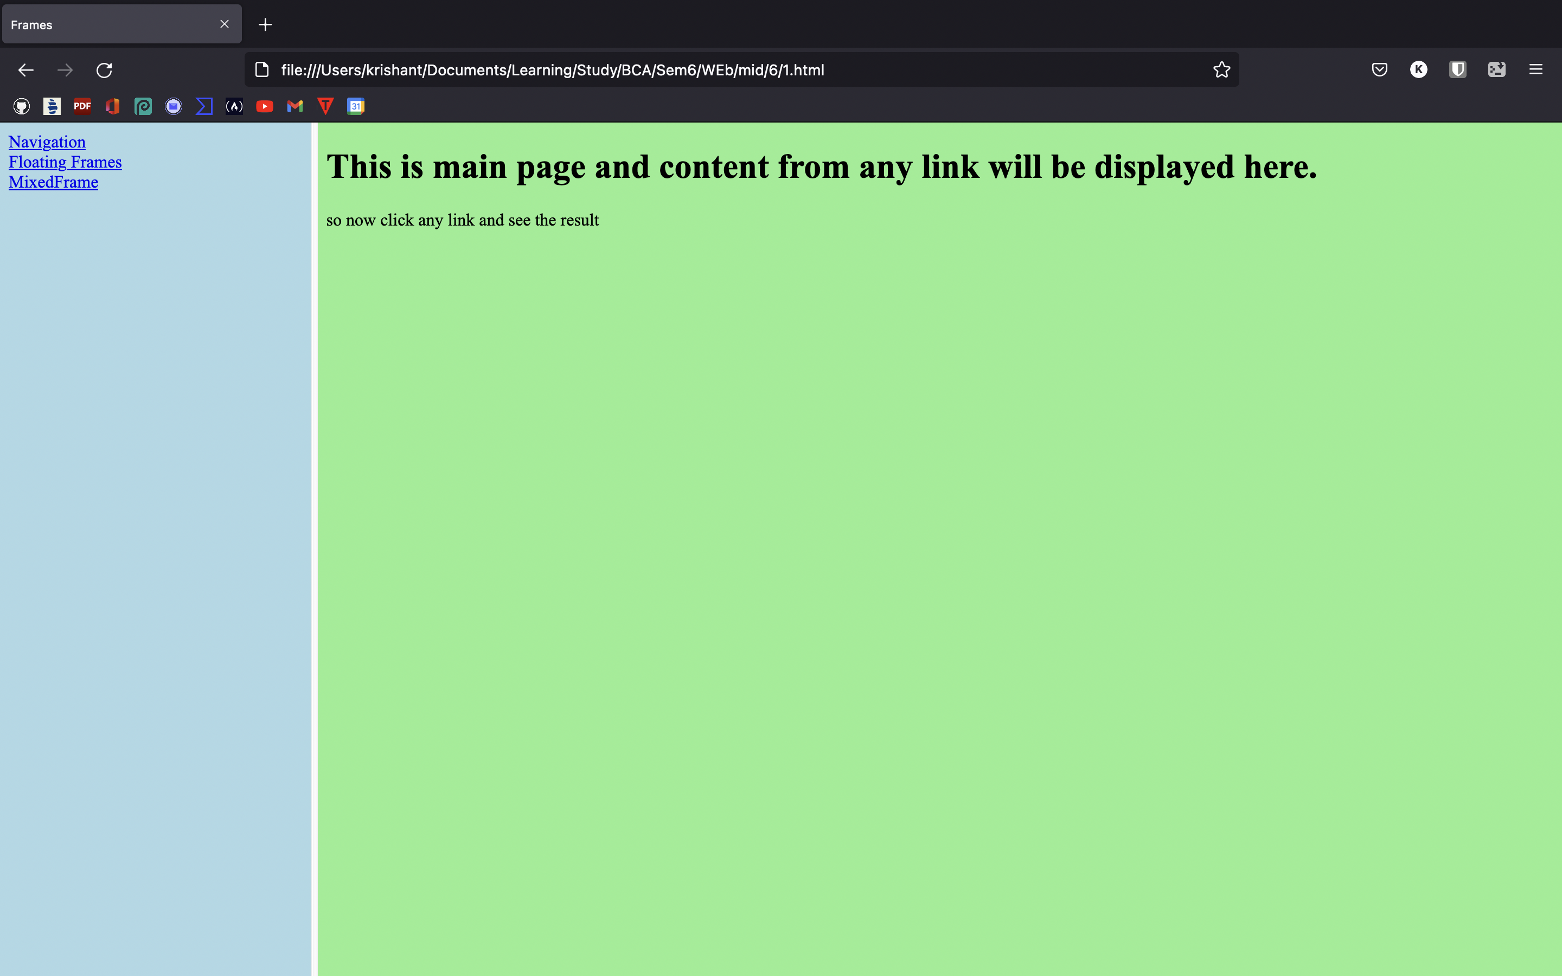 ="Navigation Frame.html">

<frame src = "framesmain.html" name="showframe">

</frameset>

</html>

**Navigation Frame.html**

<a href = "frames.html" target="showframe">frame a</a><br>

## Q7:-(a) Create a student registration form as mentioned below and link this form to the form “student information”.

## User Id

## Password

## Login

## (b) Create another form of name “Student Information” contains information as mentioned below (i) Name

## Email

## Phone number

## Gender

## Course

## Hobbies

## Date of birth

## Upload documents

## Submit

## StudentRegistration.html

<html>

<head>

<title> Student Registration Form</title>

</head>

<body>

<form autocomplete="off">

<label for="text"> User Id </label>

<input type="text" name="text2"><br> <br>

<label for="password">Password</label>

<input type="password" name="password"><br><br>

<label for="login">Login</label>

<input type="submit" name="submit"><br><br>

<a href="StudentInformation.html">Click Here for more Details</a>

</form>

</body>

</html>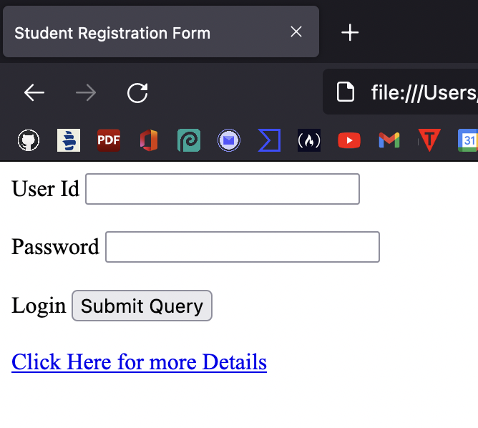

**StudentInformation.html**

<html><head>

<title> Student Registration Form</title>

</head><body>

<form autocomplete="off">

<label for="text"> Name </label>

<input type="text" name="text2"><br>

<label for="Email">Email</label>

<input type="Email" name="Email"><br>

<label for="number">Phone Number</label>

<input type="number" name="number"><br>

<label for="Gender">Gender</label><br>

<label for="male">Male</label>

<input type="radio" name="t" >

<label for="female">Female</label>

<input type="radio" name="t"> <br>

<label for="course"> Choose a course:</label>

<select name="course" id="course">

<option value="MCA">MCA</option>

<option value="BCA">BCA</option>

<option value="BBCA">Btech.</option>

</select><br><br>

<label for="Hobbies">Hobbies:</label>

<input list="Hobbies" name="Hobbie" id="course">

<datalist id="Hobbies">

<option value="Watch Series">

<option value="Online Games">

<option value="Music"></datalist><br>

<label for="DOB">Date of birth</label>

<input type="date" name="date"> <br>

<label>Upload documents</label> <br>

<input type="file" name="newfile"> <br><br

<input type="submit" name="submit"><br>

</form></body></html>

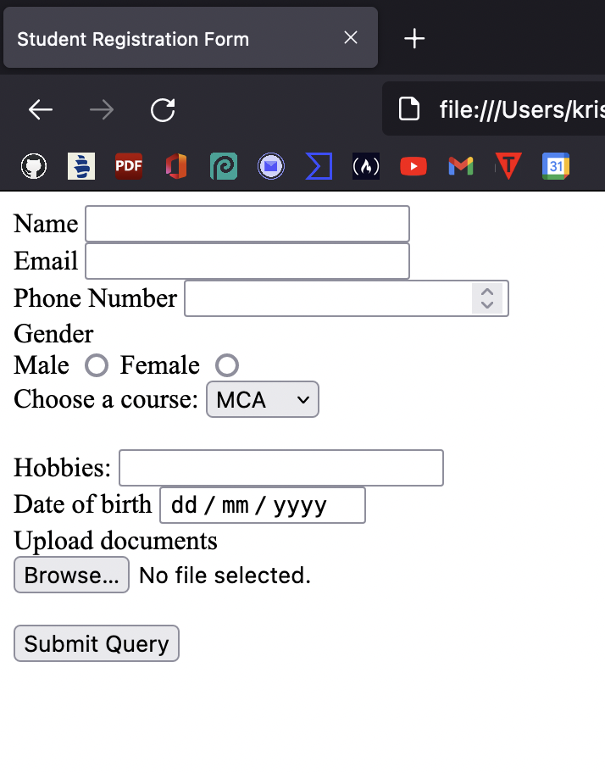

## Q8:-Write an html program and style the page as: size of the content is 30 px with impact font family; color of the content is blue; alignment is centre; background color is lightblue; text decoration of first heading is underline.

<!DOCTYPE html>

<html>

<head>

<title>Style the page </title>

<style>

p{

font-size:30px;

font-family:monospace;

color:blue; align:center;

background-color:ligtblue;}

h1{

text-decoration:underline;}

</style>

<body>

<h1>Paragraph</h1>

<p>This is the example of style of a paragraph </p>

</body>

</html>

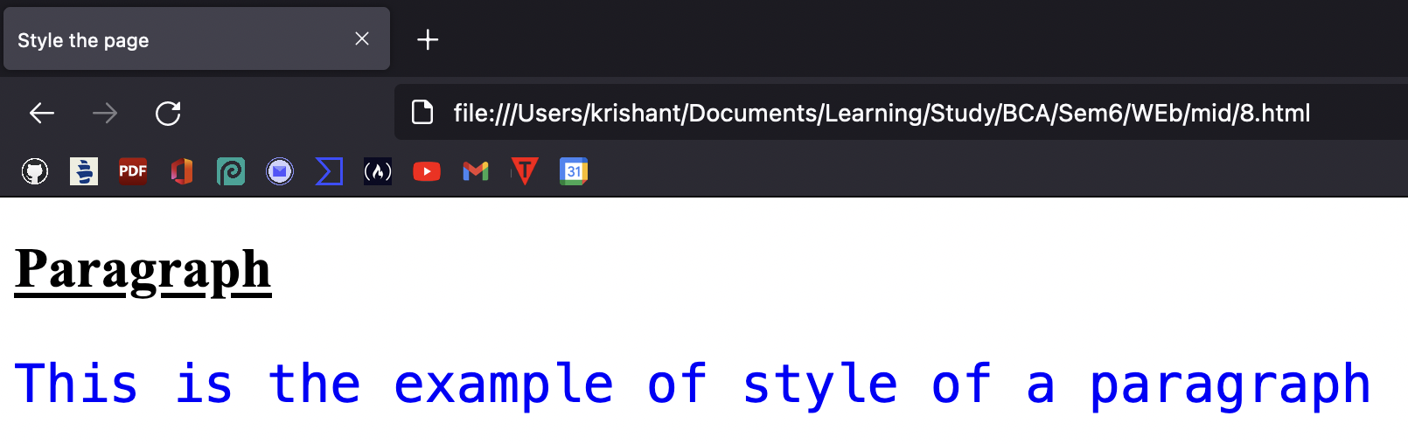

## Q9:-Write a program to set the background color of the div cyan, set the different color for the content inside div, set the different border color and width of the four border.

<!DOCTYPE html>

<html>

<head>

<title>Style the page </title>

<style>

.div {

background-color:cyan;

} .div1{ color:red;

border:2px solid green;

} .div2{ color:blue;

border:2px solid pink;

} .div3{ color:yellow;

border:2px solid blue;

} .div4{ color:red;

border:2px solid blue;

}

</style>

<body>

<div class="div">This is div color with cyan

<div class="div1">Hello </div>

<div class="div2"> How </div>

<div class="div3"> are </div>

<div class="div4"> you</div>

</div>

</body>

</html>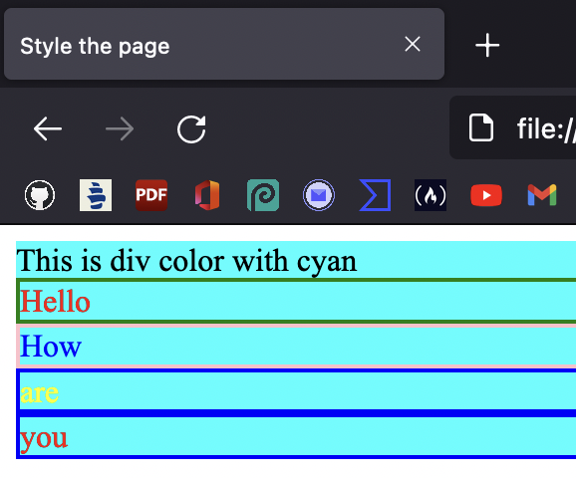

**Q10:- Write a program to demonstrate the [box model,](http://45.116.207.67/moodle/mod/url/view.php?id=5845) specify an element with a total width of 300px.**

<!DOCTYPE html>

<html>

<head>

<title>CSS Box Model Concept</title>

</head>

<body>

<style>

.main{

font-size:30px;

font-weight:bold;

Text-algin:center; }

.class1{

margin-left:60px;

border:50px solid;

width:300px;

height:200px;

text-align:center;

padding:50px; }

.class2{

font-size:42px;

font-weight:bold;

color:red;

margin-top:70px;

background-color:green; }

.class3{

font-size:18px;

font-weight:bold;

background-color:red; }

</style>

<body> <center>

<div class="main"> CSS BOX-MODEL PROPERTY</div>

<div class="class1">

<div class="class2"> Graphic Era</div>

<div class="class3"> School of Computing</div></center>

</body> </html>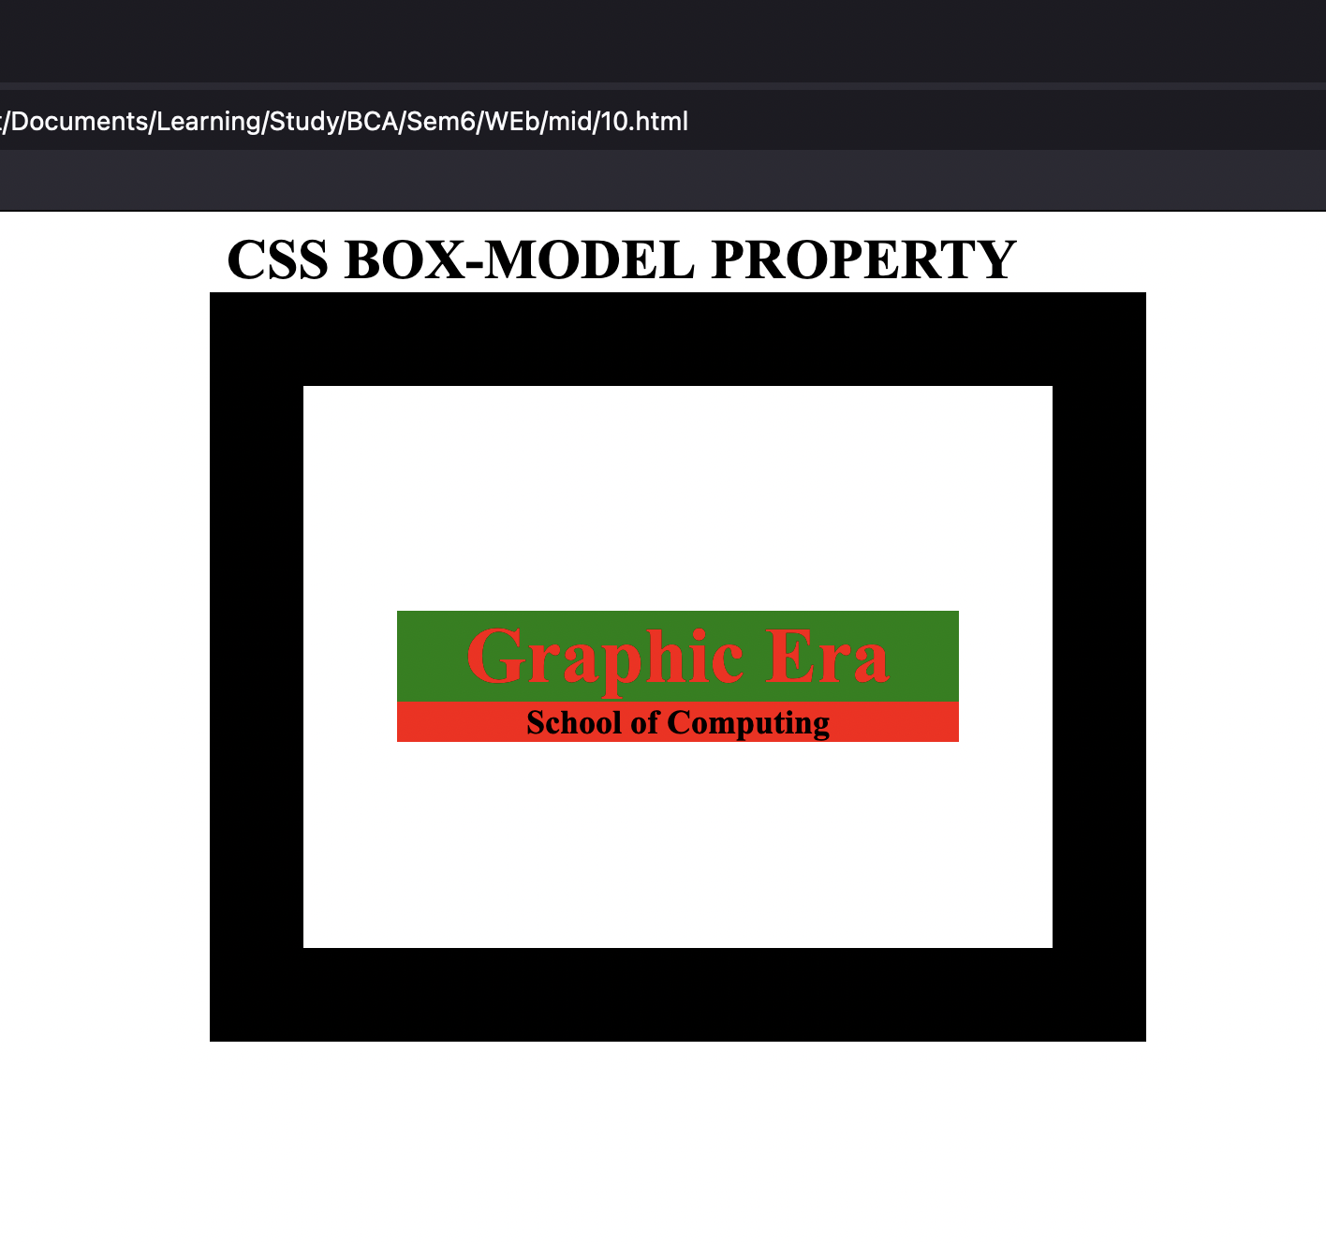

Q11:-**Write a program to add different colors and styles to hyperlinks using pseudo class.**

<!DOCTYPE html>

<html>

<head>

<title>pseudo class</title>

<style> a:link{

text-decoration:overline; color:green;

} a:visited {

text-decoration:line; color:blue; } a:hover { font-size:2em; color:hotpink;} a:active{ text-decoration:none; color:red;} </style>

<body>

<a href="#home" target="_blank">Visibility</a>

</body>

</html>

## Q12:-Create a web page which contains 4 elements (it can be a div or images) use [CSS](http://45.116.207.67/moodle/mod/url/view.php?id=5816) positioning to properly position these elements, you have to show all [CSS](http://45.116.207.67/moodle/mod/url/view.php?id=5816) position values in the web page.

<!DOCTYPE html>

<html><head>

<title>Positioning</title>

<style> .container{ height:3500px; border:2px solid green;

position:relative; }

.box{ height:200px; width:200px; border:2px solid;

margin:4px; }

#b1{ background-color:Red;

position:sticky;

top:20px; }

#b2{ background-color:Yellow; left:50px; }

#b3{ background-color:green; position:fixed; bottom:80px; right:80px;

}

#b4{

background-color:pink;

}

</style>

</head>

<body>

<div class="container">

<div class="box" id="b1">div 1 </div>

<div class="box" id="b2">div 2 </div>

<div class="box" id="b3">div 3 </div>

<div class="box" id="b4">div 4 </div>

</div></body></html>